**NATIONAL INSTITUTE OF TECHNOLOGY SILCHAR**

**Cachar, Assam**

**B.Tech. IVth Sem**

**Subject Code:** CS215

**Subject Name:** Signals and Data Communication

**Submitted By:**

Name : Subhojit Ghimire

Sch. Id. : 1912160

Branch : CSE – B

1. **Consider the message signal m(t),**

$$m\left(t\right)= \left\{\begin{aligned}sinc \left(100t\right) , \left|t\right| ≤ t_{0 } \\ 0 , otherwise\end{aligned}\right.$$

**modulates the carrier signal c(t) = cos (2πfct) using frequency modulation (FM) scheme. Assume that fc = 250Hz and t0 = 0.1 sec. The frequency sensitivity factor is kf = 100. Using sampling frequency of 1000, do the following,**

1. **Plot the integral of the message signal which you will need to use for FM.**
2. **Plot the message and the modulated signal.**
3. **Plot the spectra of message and the modulated signal.**
4. **Compare the demodulated signal with the original message signal.**

* **AIM: TO PLOT THE MODULATED SIGNAL, DEMODULATED SIGNAL AND THE ORIGINAL MESSAGE SIGNAL, ALONG WITH THE INTEGRAL AND SPECTRA OF MESSAGE FOR A GIVEN MESSAGE SIGNAL M(T) USING FREQUENCY MODULATION SCHEME.**

**THEORITICAL BACKGROUND:**

1. **Message Signal:** The signal which contains a message to be transmitted, is called as a message signal.
2. **Carrier Signal:** It is a sinusoidal signal that is used in the modulation.
3. **Frequency Modulation Signal:** It is an information encoded signal in carrier wave obtained by changing the instantaneous frequency of the wave.
4. **Modulated Signal:** It is a signal using which the modulation process is carried out, i.e, the properties of the periodic waveform is varied using a separate signal called the modulated signal.
5. **Demodulated Signal:** This signal is used in extracting the original information-bearing signal from the carrier wave in the process of demodulation.
6. **Spectra of the message:** It describes the message signal’s magnitude and phase characteristics as a function of frequency.
7. The Hilbert Transform is defined as

$$H \left\{x\left(t\right)\right\}=x\left(t\right)= \frac{1}{π}\int_{-∞}^{+∞}{\frac{x(τ)}{t-τ}dτ=x\left(t\right)*\frac{1}{πτ}}$$

The analytic equation is written as: $a\left(t\right)=x\left(t\right)+j\hat{x}(t)$

The instantaneous phase is: $φ\left(t\right)=arctan\frac{\hat{x}(t)}{x(t)}$

And the frequency is: $f\left(t\right)= \frac{1}{2π}∙\frac{dφ(t)}{dt}$

Thus, the Hilbert transform can be used to demodulate an FM signal, where the message signal is in the argument of the carrier as its frequency.

**METHODOLOGY:**

1. The modulated signal is taken and its phase is detected.
2. The envelope of the phase is found using the MATLAB function “envelope”.
3. The envelope is differentiated and divided by 2πfk to obtain the message.
4. The effect of 2π phase folding is undid and the phase is restored using the MATLAB function “unwrap”.
5. The message, its integral and the modulated signal is generated.
6. The frequency spectrum of message and modulated carrier is generated.
7. The Hilbert transform of modulated carrier is computed using the **hilbert** function which returns the complex analytical function.
8. The argument of the Hilbert transform is differentiated and approximately scaled, thus resulting in the original signal.

**CODE:**

clear all;

clc;

fs = 1000;

dt = 1 / fs;

t = (-0.2:dt:0.2)';

t0 = 0.1;

m = sinc (100*t);

m (t < -t0) = 0;

m (t > t0) = 0;

figs(1) = figure;

subplot (2, 2, 1);

mPlt = gca;

plot (t, m, 'k');

grid on;

pbaspect ([2 1 1]);

axis ([-0.2, 0.2, -0.4, 1.2]);

title ('Message Signal');

xlabel ('{\itt}(seconds)');

subplot (2, 2, 2);

mCum = cumtrapz (t, m);

mCumPlt = gca;

plot (t, mCum, 'k');

grid on;

pbaspect ([2 1 1]);

title ('Integral of Message Signal');

xlabel ('{\itt} (seconds)');

fc = 250;

Kf = 100;

s = cos (2*pi*fc*t + 2*pi*Kf*mCum);

subplot (2, 2, 3);

sPlt = gca;

plot (t, s, 'k');

grid on;

pbaspect ([2 1 1]);

axis ([-0.2, 0.2, -1.5, 1.5]);

title ('Modulated Carrier');

xlabel ('{\itt} (seconds)');

mft = fft(m);

N = length(m);

mfreq = (-N/2:N/2 - 1)' * (fs/N);

figs(2) = figure;

subplot (2, 2, 1);

mftPlt = gca;

plot (mfreq, abs(fftshift(mft)), 'k');

grid on;

pbaspect ([2 1 1]);

mfreqRange = mfreq(end)/2;

axis ([-mfreqRange, mfreqRange, 0, 12]);

title ('Spectra of Message Signal');

xlabel ('{\itf} (Hz)');

sft = fft(s);

N = length (s);

sfreq = (-N/2:N/2 - 1)' * (fs/N);

subplot (2, 2, 2);

sftPlt = gca;

plot (sfreq, abs(fftshift(sft)), 'k');

grid on;

pbaspect ([2 1 1]);

axis ([0, sfreq(end), 0, 200]);

title ('Spectra of Modulated Signal');

xlabel ('{\itf} (Hz)');

sH = hilbert(s) .* exp (-i * 2*pi*fc * t);

mR = (1/(2*pi*Kf)) * [0; diff(unwrap(angle(sH))) * fs];

subplot (2, 2, 3);

mRPlt = gca;

plot (t, mR, 'r', t, m, 'k');

grid on;

pbaspect ([2 1 1]);

axis ([-0.2, 0.2, -0.4, 1.2]);

title ('Spectra of Demodulated Signal');

legend ({'Demodulated Signal', 'Original Signal'});

xlabel ('{\itt} (seconds)');

subplot (2, 2, 4);

errPlt = gca;

plot (t, abs(mR - m), 'k');

grid on;

pbaspect ([2.5 1 1]);

axis ([-0.2, 0.2, -0.05, 0.2]);

title ('Absolute Error in Demodulation');

xlabel ('{\itt} (seconds)');

**INPUT DATA DESCRIPTION:**

The message single is

$$m\left(t\right)= \left\{\begin{aligned}sinc \left(100t\right) , \left|t\right| ≤ t_{0 } \\ 0 , otherwise\end{aligned}\right.$$

Where, the normalised sinc function is $\frac{sin(πt)}{πt}$.

The carrier signal is cos (2πfct).

Carrier frequency, fc = 250 Hz, t0 = 0.1 sec

Frequency sensitivity, kf = 100

Sampling frequency, fs = 1000 Hz

**RESULT:**

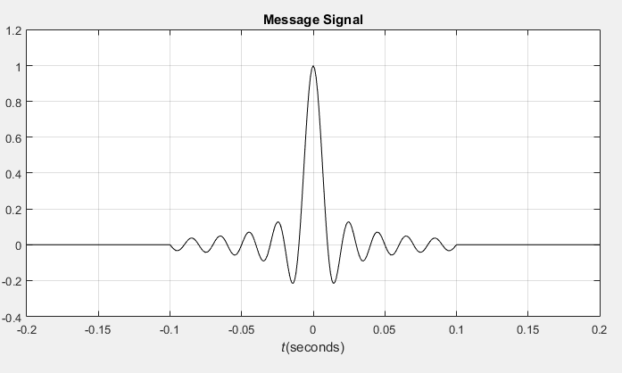

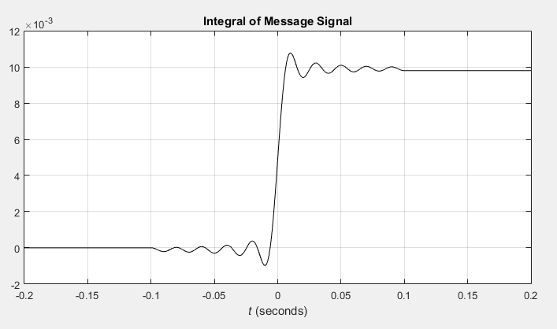

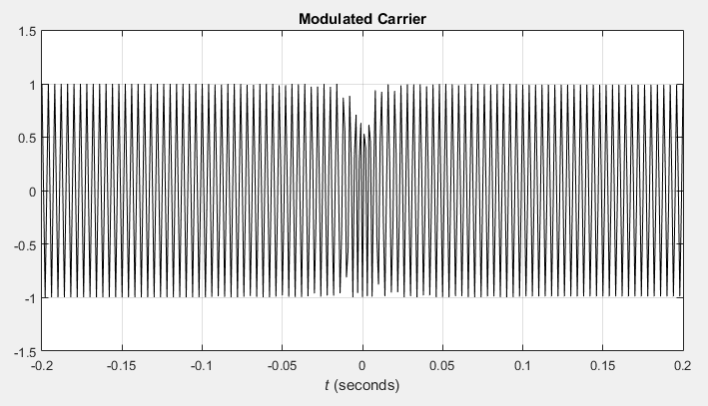

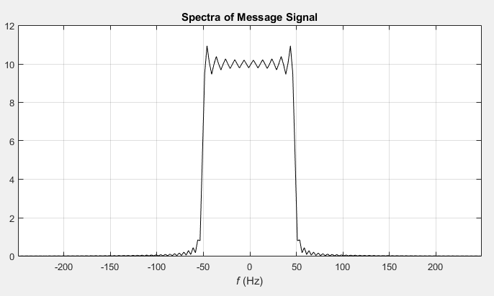

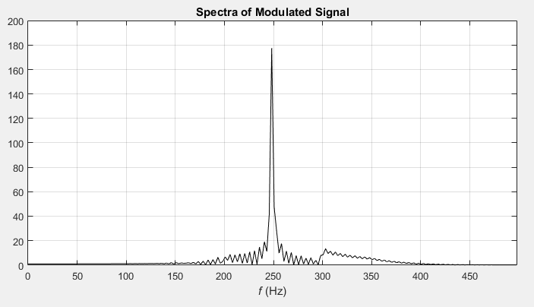

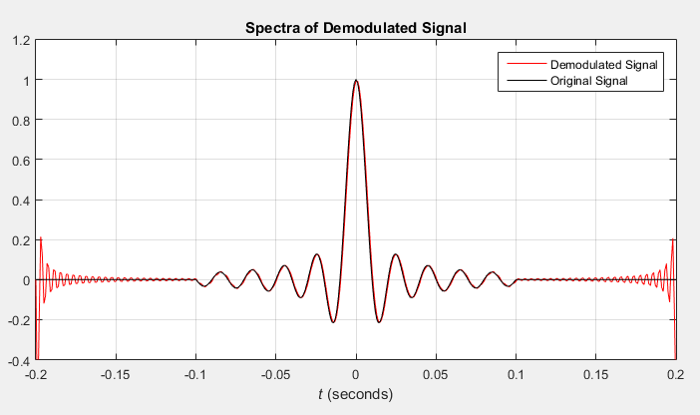

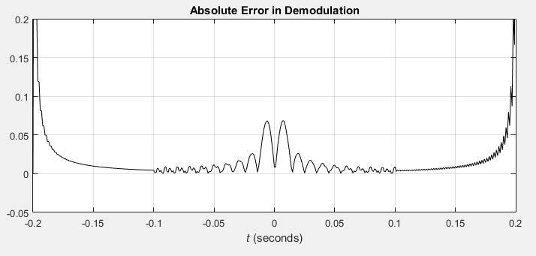

**CONCLUSION/DISCUSSION:**

The demodulated signal is thus, a close approximation of the original signal. There is a significant divergence at the end of the time ranges in demodulated signal. This is similar to Gibb’s phenomenon and can be minimised by using a higher sampling rate.